A NOVEL METHOD FOR HANDWRITTEN DIGIT RECOGNITION SYSTEM

TEAM ID | PNT22022TMID32105
PROJECT NAME | A NOVEL METHOD FOR HANDWRITTEN DIGIT RECOGNITION SYSTEM
TEAM MEMBERS | SHIVA SURYA VASAN S  SURYAPRAKASH S  SUDHARSON D  BOOPATHI S

A PROJECT REPORT
CONTENTS
- INTRODUCTION
  - Project Overview
  - Purpose
- LITERATURE SURVEY
  - Existing problem
  - References
  - Problem Statement Definition
- IDEATION & PROPOSED SOLUTION
  - Empathy Map Canvas
  - Ideation & Brainstorming
  - Proposed Solution
  - Problem Solution fit
- REQUIREMENT ANALYSIS
  - Functional requirement
  - Non-Functional requirements
- PROJECT DESIGN
  - Data Flow Diagrams
  - Solution & Technical Architecture
  - User Stories
- PROJECT PLANNING & SCHEDULING
  - Sprint Planning & Estimation
  - Sprint Delivery Schedule
  - Reports from JIRA
- CODING & SOLUTIONING (Explain the features added in the project along with code)
  - Feature 1
  - Feature 2
  - Database Schema (if Applicable)
- TESTING
  - Test Cases
  - User Acceptance Testing
- RESULTS
  - Performance Metrics
- ADVANTAGES & DISADVANTAGES
- CONCLUSION
- FUTURE SCOPE
- APPENDIX
Source Code, GitHub & Project Demo Link
1. INTRODUCTION
1.1 PROJECT OVERVIEW
Handwritten digit recognition using MNIST dataset is a major project made with the help of Neural Network. It basically detects the scanned images of handwritten digits. We have taken this a step further where our handwritten digit recognition system not only detects scanned images of handwritten digits but also allows writing digits on the screen with the help of an integrated GUI for recognition.

Approach:
We will approach this project by using a three-layered Neural Network.
The input layer: It distributes the features of our examples to the next layer for calculation of activations of the next layer.
The hidden layer: They are made of hidden units called activations providing nonlinear ties for the network. A number of hidden layers can vary according to our requirements.
The output layer: The nodes here are called output units. It provides us with the final prediction of the Neural Network on the basis of which final predictions can be made.
A neural network is a model inspired by how the brain works. It consists of multiple layers having many activations, this activation resembles neurons of our brain. A neural network tries to learn a set of parameters in a set of data which could help to recognize the underlying relationships. Neural networks can adapt to changing input; so the network generates the best possible result without needing to redesign the output criteria.

Methodology:
We have implemented a Neural Network with 1 hidden layer having 100 activation units (excluding bias units). The data is loaded from a .mat file, features(X) and labels(y) were extracted. Then features are divided by 255 to rescale them into a range of [0, 1] to avoid overflow during computation. Data is split up into 60,000 training and 10,000 testing examples. Feed forward is performed with the training set for calculating the hypothesis and then back propagation is done in order to reduce the error between the layers. The regularization parameter lambda is set to 0.1 to address the problem of over fitting. Optimizer is run for 70 iterations to find the best fit model.

1.2 PURPOSE
  - The issue of transcribed digit acknowledgment has for some time been an open issue in the field of example order. A few examined have demonstrated that Neural Network has an incredible execution in information arrangement. The fundamental target of this paper is to give effective and solid procedures to acknowledgment of transcribed numerical by looking at different existing arrangement models. This paper thinks about the exhibition of Convolutional Neural Network (CCN). Results demonstrate that CNN classifier beat over Neural Network with critical improved computational effectiveness without relinquishing execution. Handwritten digit recognition can be performed using the Convolutional neural network from Machine Learning.
  - Using the MNIST (Modified National Institute of Standards and Technologies) database and compiling with the CNN gives the basic structure of my project development. So, basically to perform the model we need some libraries such as, ‘Pandas’, Tensor Flow. These are the main structure on which my main project stands. MNIST data contains about 70,000 images of handwritten digits from 0-9. So, it is a class 10 classification model. This dataset is divided into 2 parts i.e. Training and Test dataset. Image representation as 28*28 matrix where each cell contains grayscale pixel value.

2. LITERATURE SURVEY
2.1 EXISTING PROBLEM
- Handwritten Digit Recognition System involves reception and interpretation of handwritten digits by a machine. Due to variation in shape and orientation of handwritten digits, it is difficult for a machine to interpret handwritten digits. Handwritten digit Recognition has a wide area of research due to its vast applications like automatic bank processing, billing and automatic postal service. In this thesis, an Offline Handwritten Digit Recognition, first part is feature extraction from handwritten images and the second one is classification of feature vector into digits.

We propose descriptors for handwritten digit recognition based on Histogram of Oriented Gradient (HOG) feature. It is one of the widely used feature vector for object detection in computer vision.
For classification of features, linear Proximal Support Vector Machine Classifier is proposed. This is a binary class classifier which is further converted to a 10-class classifier by means of One against all algorithm. Due to small training time, PSVM classifier is preferable over standard Support Vector Machine (SVM) Classifier. The handwritten images both for training and testing are taken from MNIST database. The performance of the system is measured in terms of Sensitivity, Accuracy, Positive Predictively and Specificity.
- The handwritten digit recognition problem becomes one of the most notorious problems in machine” “literacy and computer vision operations. numerous machine literacy ways have been employed to break the handwritten number recognition problem. This paper focuses on Neural Network (NN) approaches. The three most” “popular NN approaches are deep neural network (DNN), deep belief network (DBN) and convolutional neural “network (CNN). In this paper, the three NN approaches are compared and estimated in terms of numerous factors” “similar as delicacy and performance. Recognition delicacy rate and performance, still, isn't the only criterion in the evaluation process, but there are intriguing criteria similar as prosecution time. Random and
standard dataset of handwritten number have been used for conducting the trials. The results show that among the three NN approaches, DNN is the most accurate algorithm; it has98.08 delicacy rate. still, the prosecution time of DNN is similar with the “other two algorithms.
- Character recognition plays an important role in the modern world. It can solve more complex problems and makes humans’ job easier. An example is handwritten character recognition. This is a system widely used in the world to recognize zip code or postal code for mail sorting. There are different techniques that can be used to recognize handwritten characters. Two techniques researched in this paper are Pattern Recognition and Artificial Neural Network (ANN). Both techniques are defined and different methods for each technique is also discussed. Bayesian Decision, and Linear Classification or Discrimination is types of methods for Pattern Recognition. Shape recognition, Chinese Character and Handwritten Digit recognition uses Neural Network to recognize them. Neural Network is used to train and identify written digits. After training and testing, the accuracy rate reached 99%. This accuracy rate is very high.
- Handwriting recognition has gained a lot of attention in the field of pattern recognition and machine learning due to its application in various fields. Optical Character Recognition (OCR) and Handwritten Character Recognition (HCR) has specific domain to apply. Various techniques have been proposed to for character recognition in handwriting recognition system. Even though, sufficient studies and papers describes the techniques for converting textual content from a paper document into machine readable form. In coming days, character recognition system might serve as a key factor to create a paperless environment by digitizing and processing existing paper documents.
- Handwritten digit recognition has recently been of very interest among the researchers because of the evolution of various Machine Learning, Deep Learning and Computer Vision algorithms. In this report, we compare the results of some of the most widely used Machine Learning Algorithms like CNN- convolution neural networks and with
Deep Learning algorithm like multilayer CNN using Keras with Theano and TensorFlow. MNIST is a dataset which is widely used for handwritten digit recognition. The dataset consists of 60,000 training images and 10,000 test images. The artificial neural networks can all most mimic the human brain and are a key ingredient in image processing field. For example, Convolution Neural networks with back propagation for image processing. The applications where these handwritten digits recognition can be used are Banking sector where it can be used to maintain the security pin numbers, it can be also used for blind peoples by using sound output.

2.2 REFERENCES
- https://www.ijnrd.org/papers/IJNRD1704024.pdf
- https://www.irjet.net/archives/V9/i6/IRJET-V9I6208.pdf
- https://citeseerx.ist.psu.edu/viewdoc/download?doi=10.1.1.228.158&rep=rep1&type=pdf
- http://ijcsit.com/docs/Volume%207/vol7issue1/ijcsit2016070101.pdf
- http://troindia.in/journal/ijcesr/vol6iss6part2/32-36.pdf

2.3 PROBLEM STATEMENT DEFINITION

Problem Statement 1

Problem Statement 2
Problem Statement 3
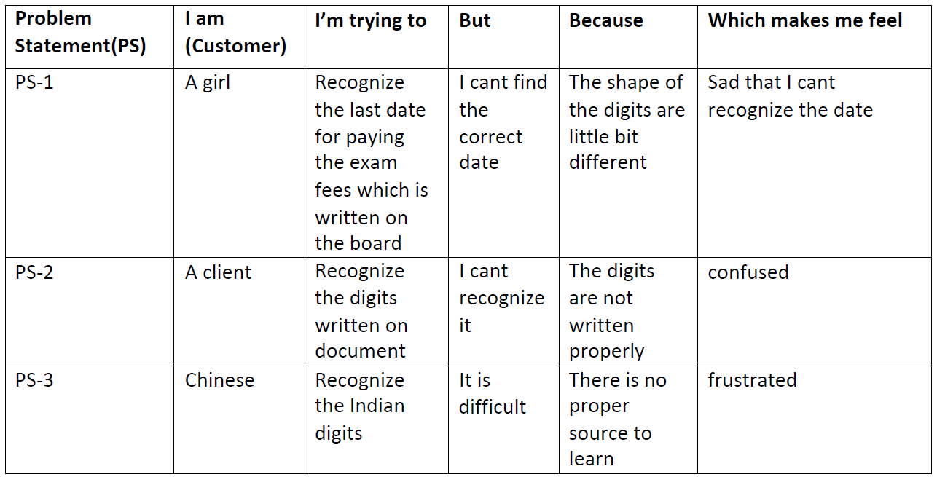

3. IDEATION & PROPOSED SOLUTION
3.1 EMPATY MAP CANVAS
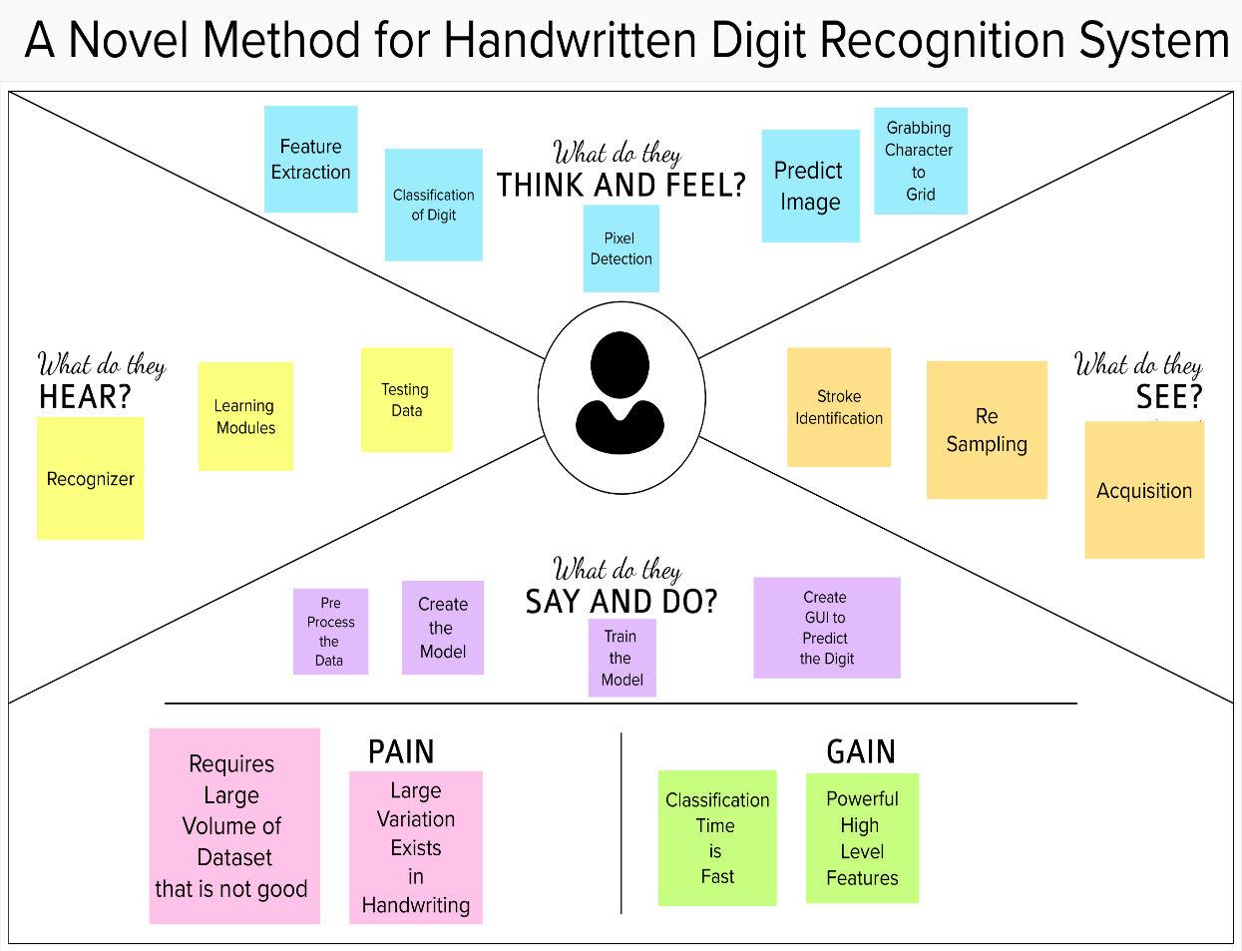

3.2 IDEATION & BRAINSTROMING

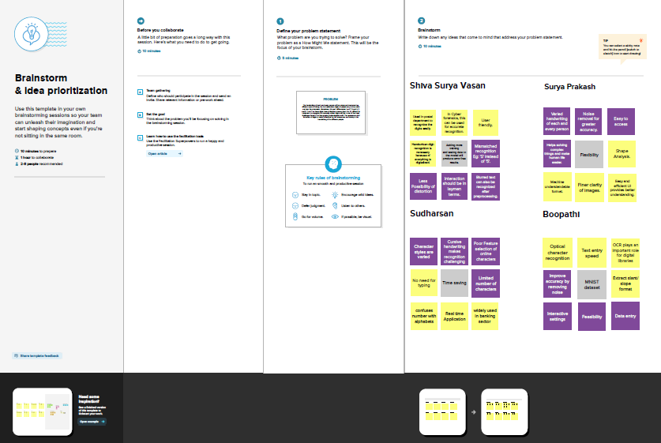
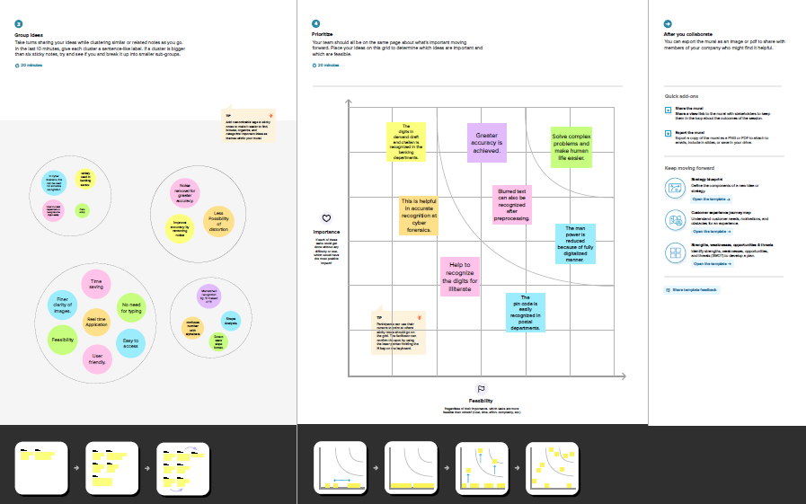

3.3 PROPOSED SOLUTION
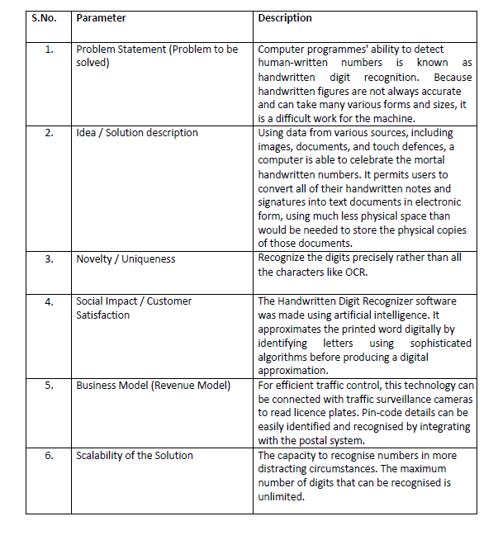

3.4 PROBLEM SOLUTION FIT
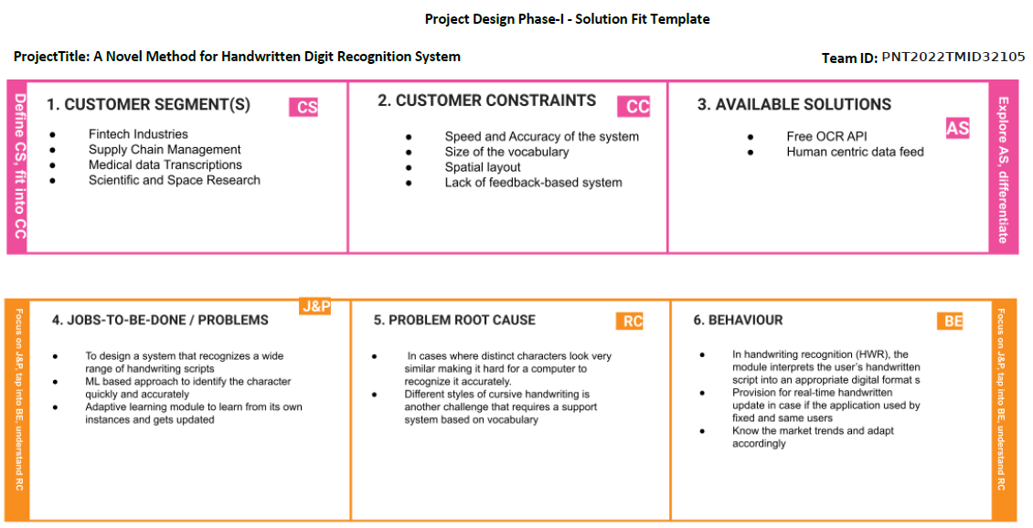

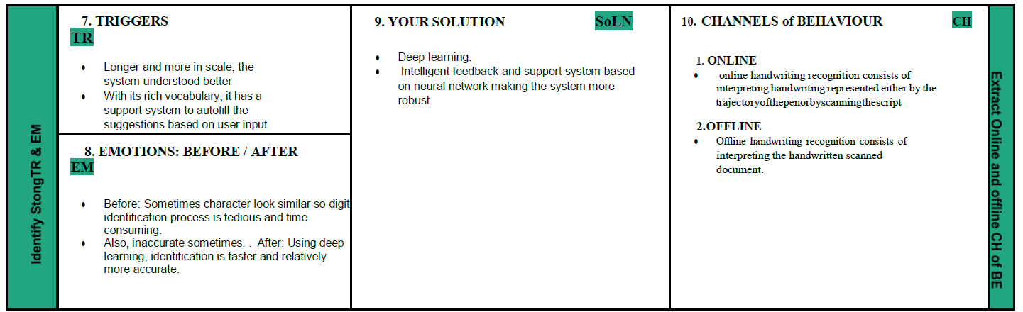

4. REQUIREMENT ANALYSIS
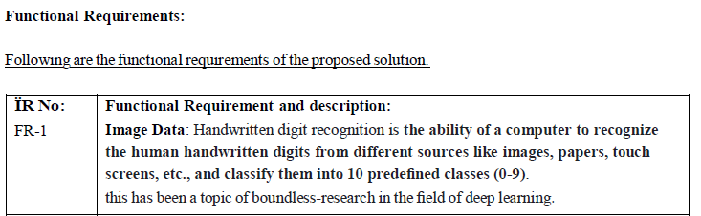

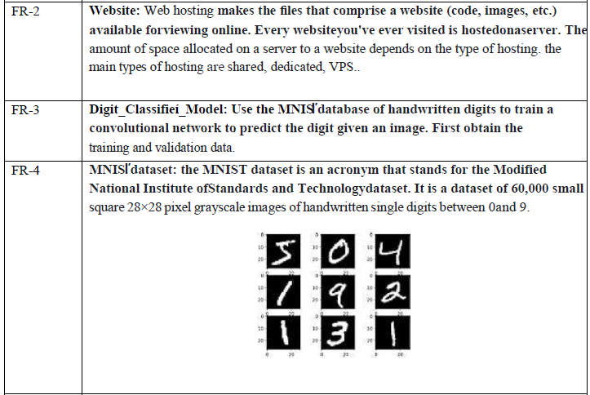

4.2 NON FUNCTIONAL REQUIREMENTS
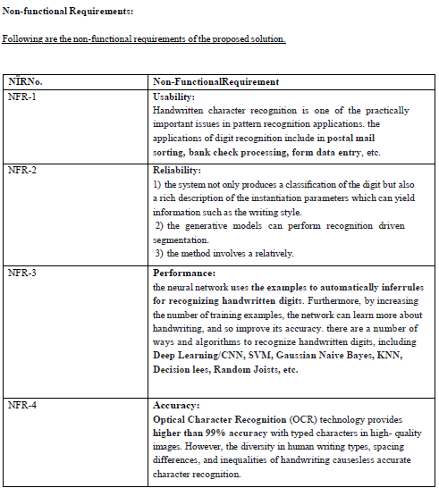

5. PROJECT DESIGN
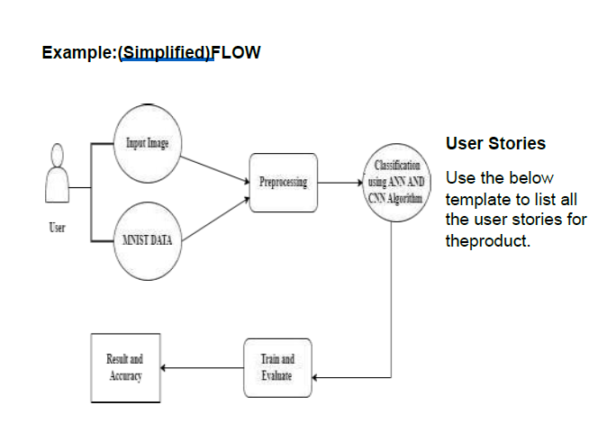
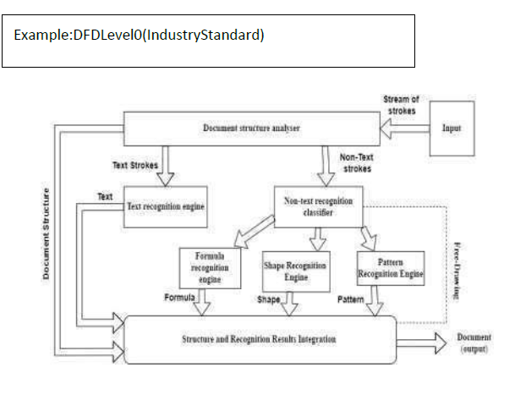

  - SOLUTION & TECHNICAL ARCHITECTURE
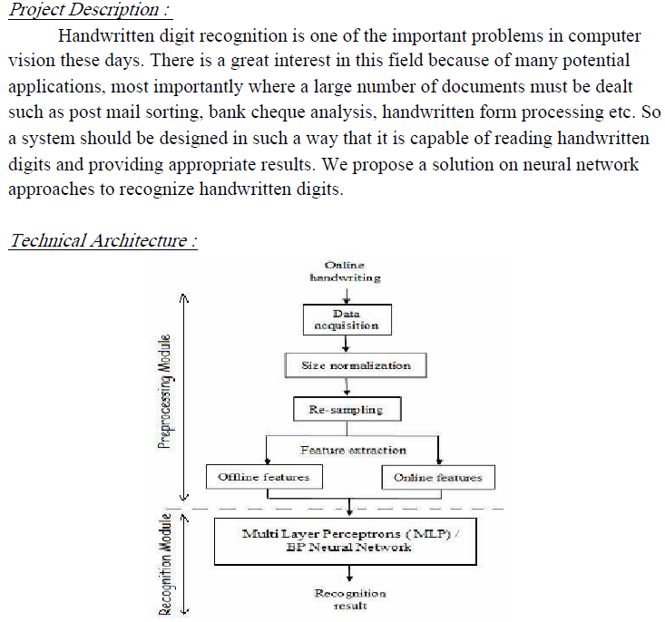
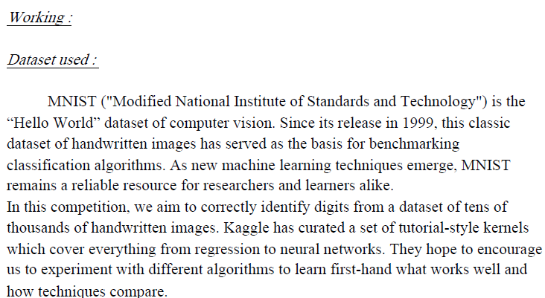

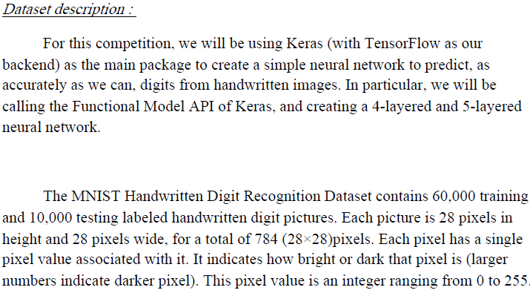
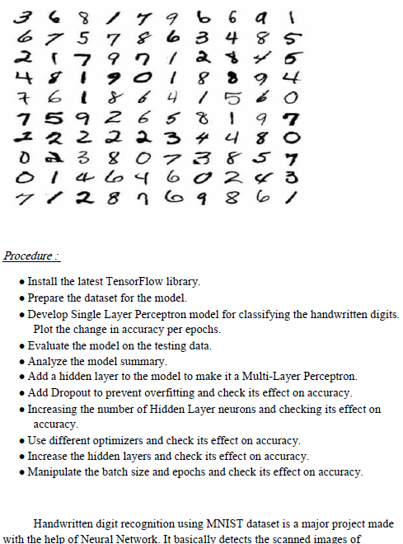

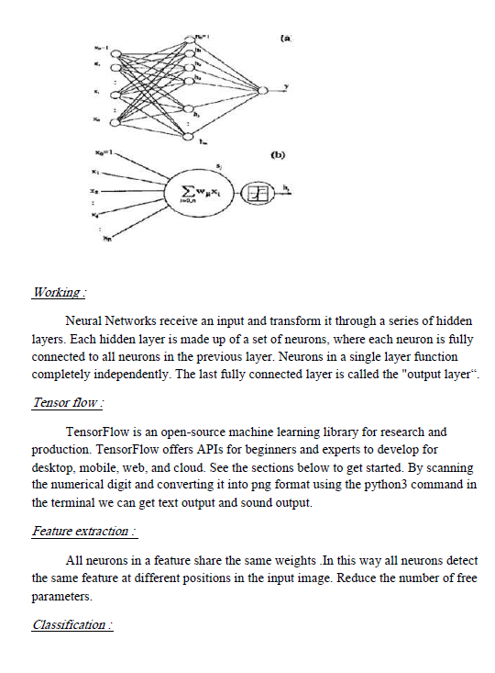

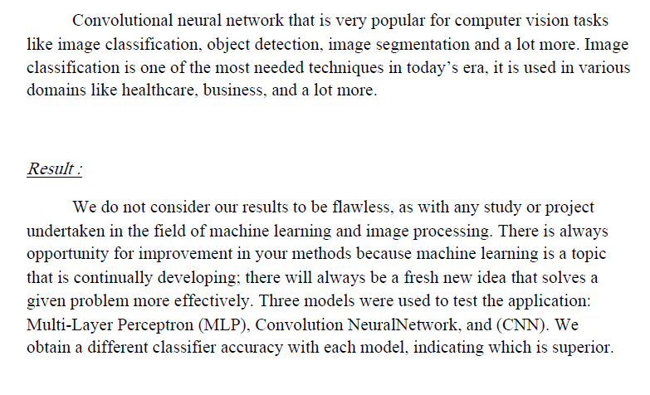
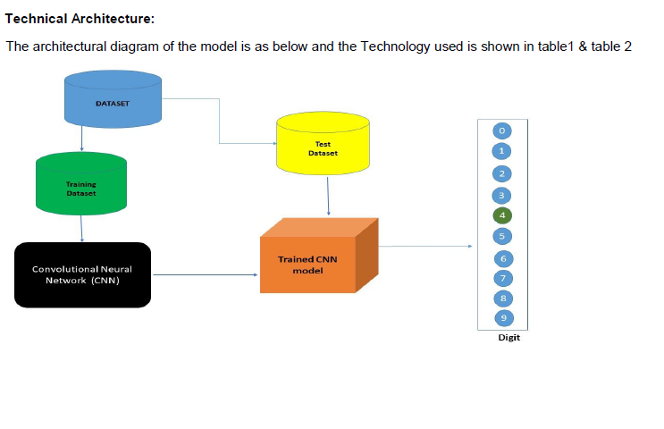

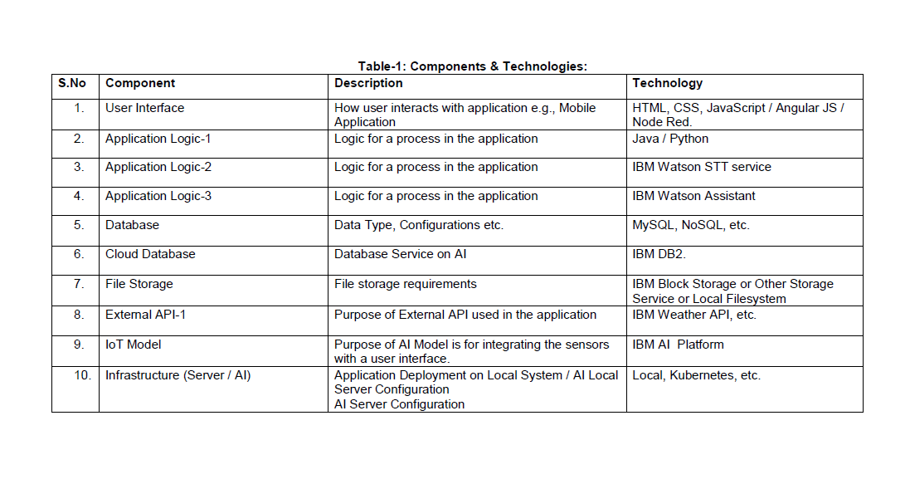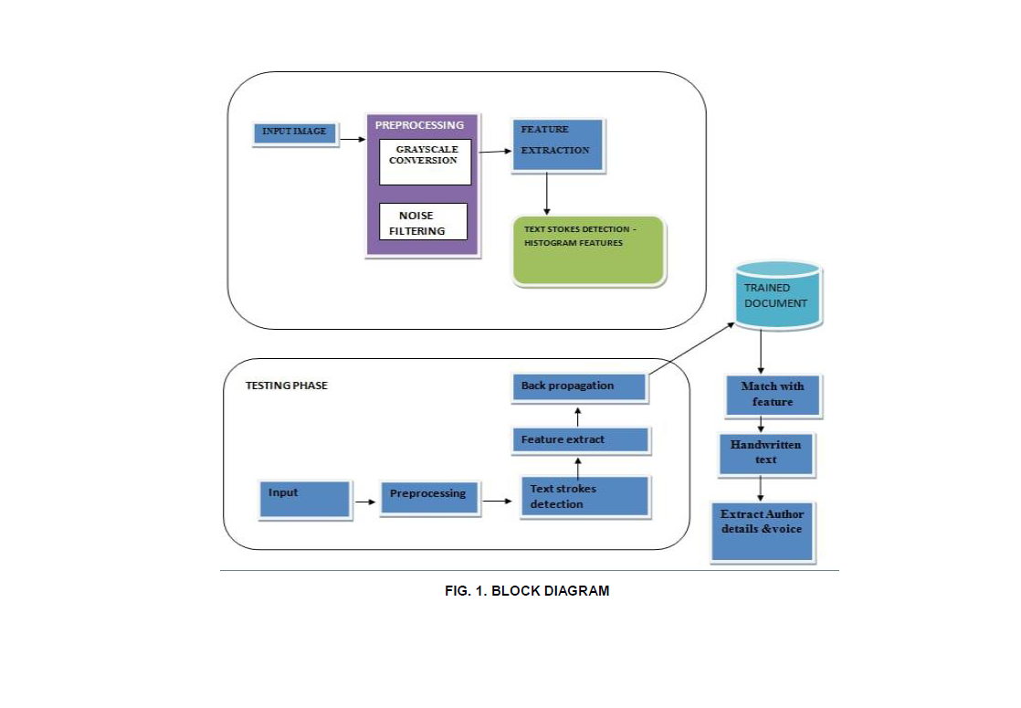

  - USER STORIES

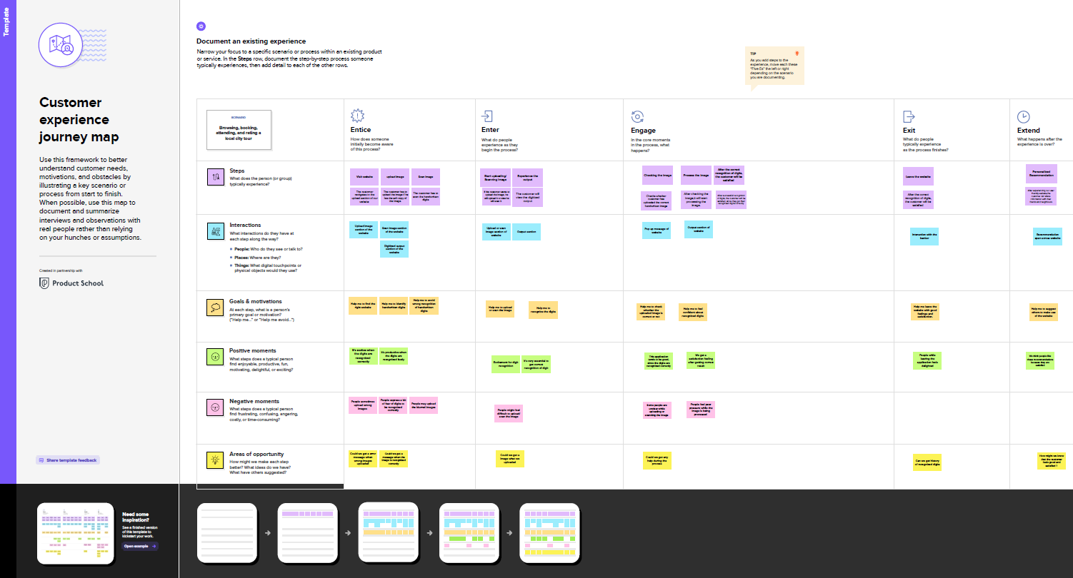

6. PROJECT PLANNING & SCHEDULING
6.1 SPRINT PLANNING & ESTIMATION
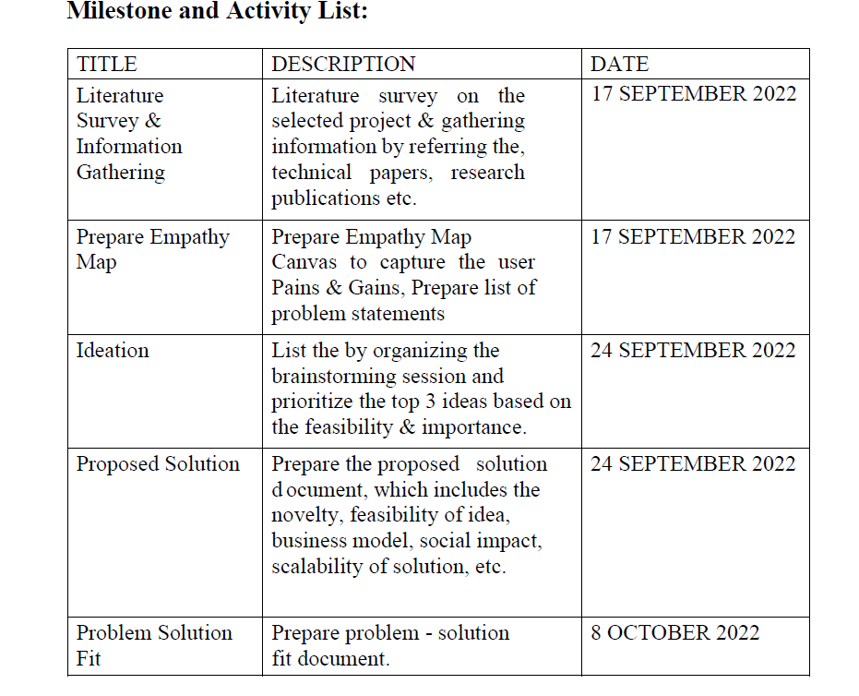
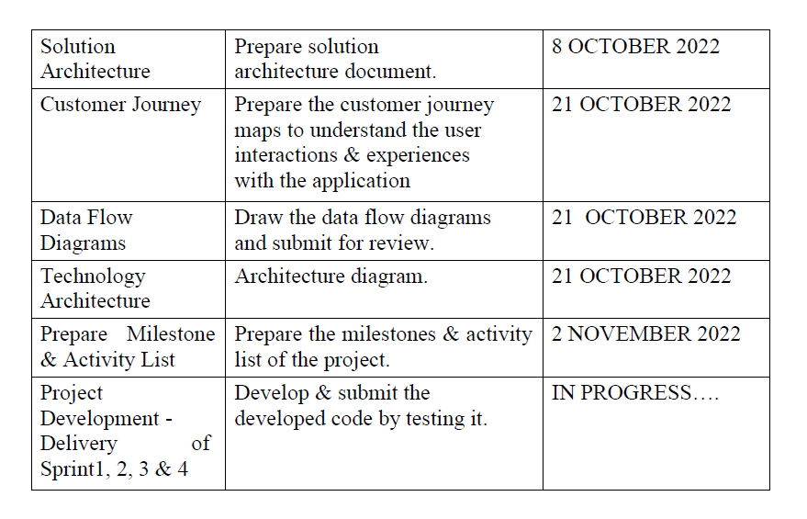

6.2 SPRINT DELIVERY SCHEDULE
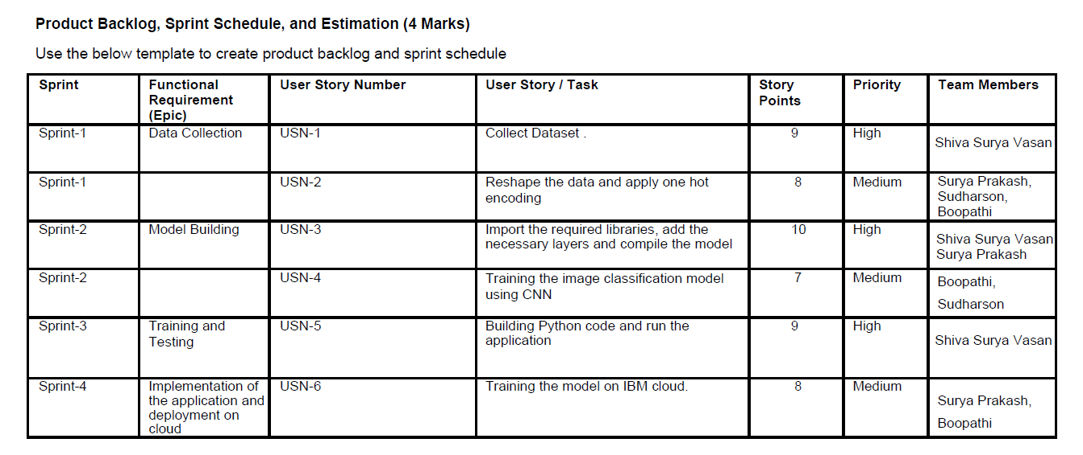
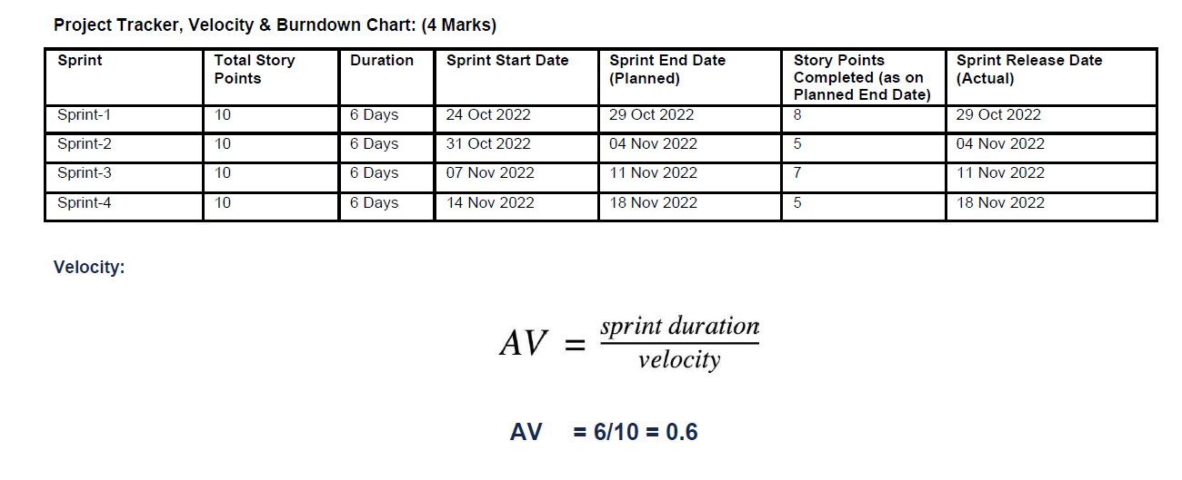
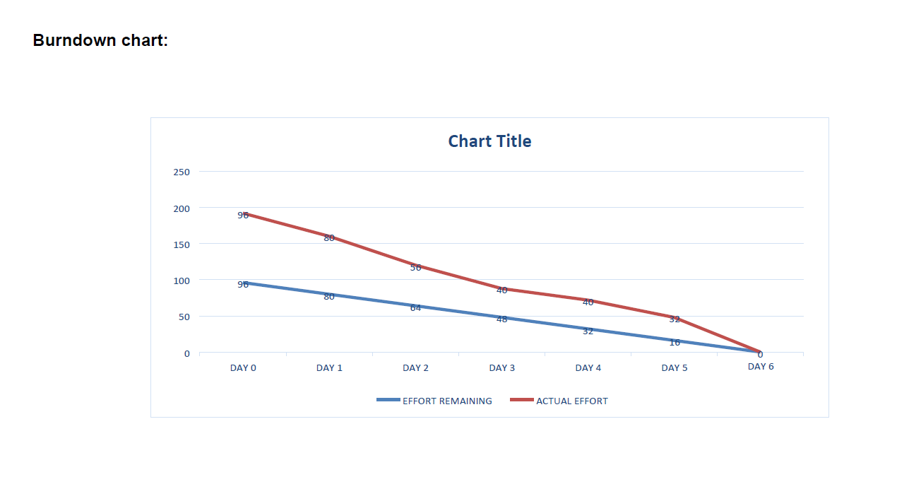

7. CODING & SOLUTIONING
7.1 FEATURE 1

- Would you like to know how to measure the accuracy of your Machine Learning model? Do you wonder if high accuracy automatically means good performance? Are you trying to measure accuracy on multiclass and multilabel problems?

7.2 FEATURE 2
    - Accuracy is perhaps the best-known Machine Learning model validation method used in classification problems. One reason for its popularity is its relative simplicity. It is easy to understand and easy to implement. Accuracy is a good metric to assess model performance for simple cases.

- However, modeling problems are rarely simple. You need to work with imbalanced datasets or in a multiclass or multilabel setting. A high accuracy might not even be your goal.
- As you solve more complex Machine Learning problems, calculating and using accuracy becomes less obvious and requires extra consideration.

7.3 DATABASE SCHEMA (IF APPLICABLE)
- For this reason, it is important to understand what accuracy is, how to calculate it, and what its weaknesses are in different Machine Learning contexts.
- Accuracy = TP + TN / TP + FP + TN + FN.
- Accuracy = Number of Correct Predictions / Total No Of Predictions

8. TESTING
8.1 TEST CASE
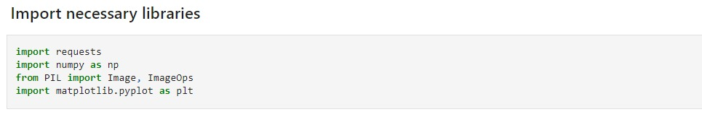
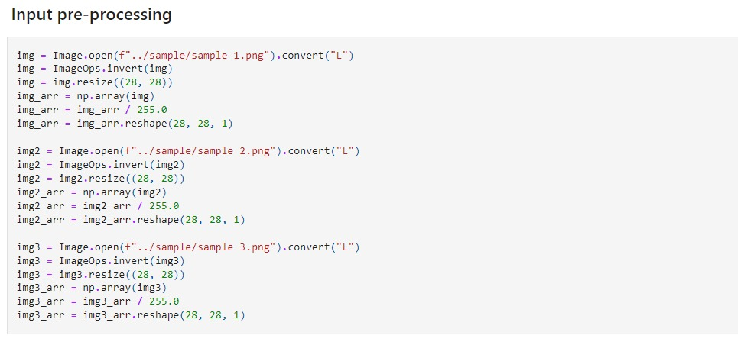
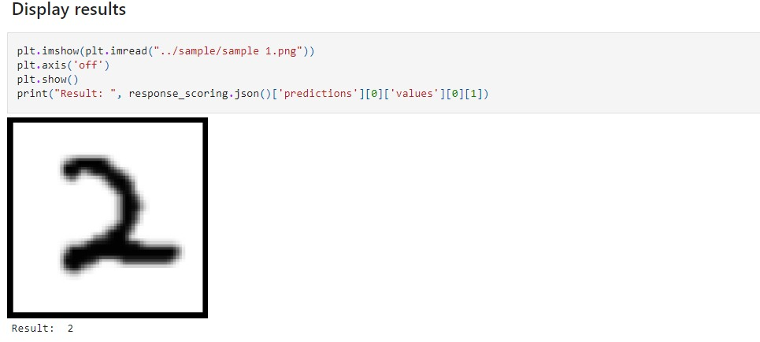
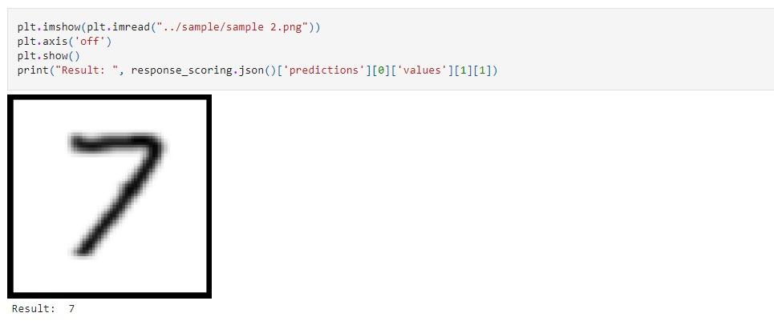

8.2 USER ACCEPTANCE TESTING
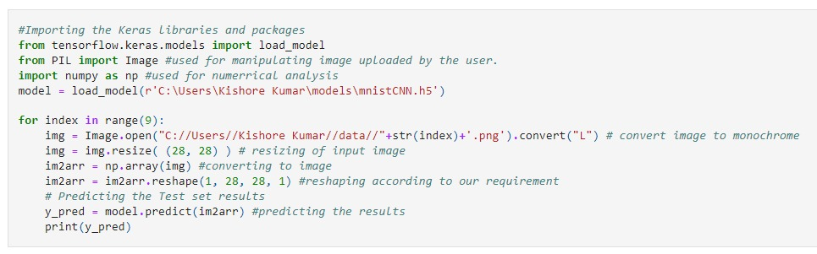
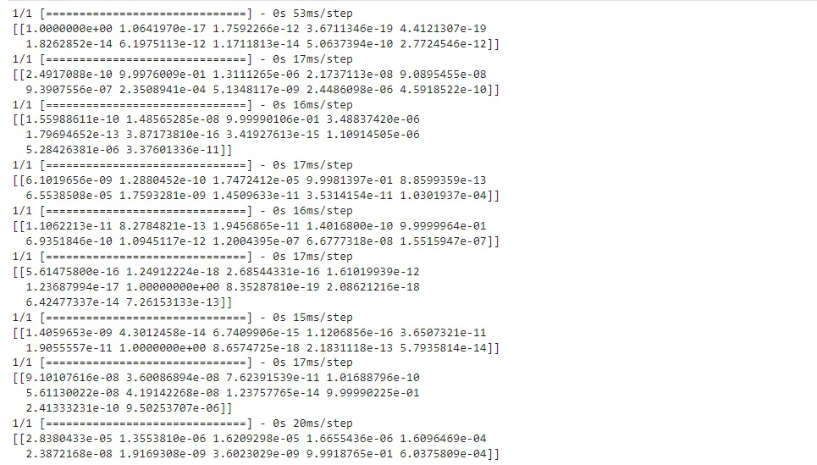
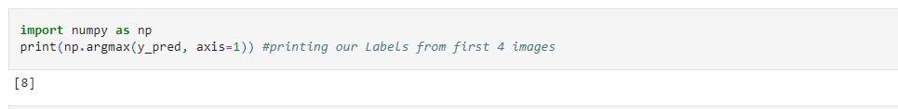

9. RESULTS
9.1 PERFORMANCE METRICS
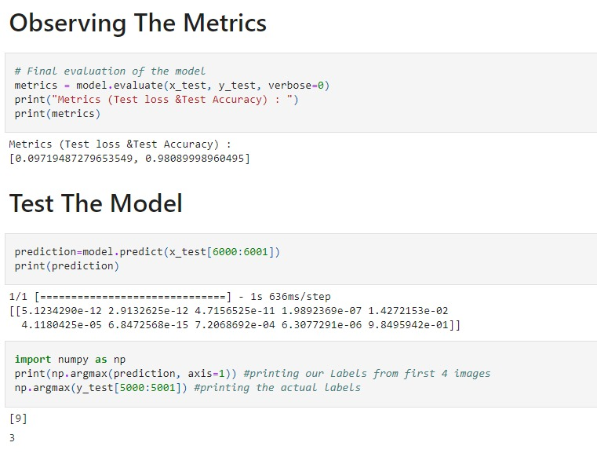

10. ADVANTAGES & DISADVANTAGES
- ADVANTAGE
- Information of images can be readable with high degree of accuracy. Flatbed scanners are very accurate and may produce reasonably top quality results.
- Processing of DL information is fast. Large quantities of text are often input quickly.
- It takes less time to convert within the Digital form Advanced version can even Recreate.

- DISADVANTAGE
- Not 100% accurate, there are likely to be some mistakes made during the method.

11. CONCLUSION
- The proposed handwritten recognition system recognizes the letters with acceptable accuracy. Extraction of small and capital letters is done separately.
- In future the small letters and capital letters can be integrated. There is a Scope for Recognition of digits and Special symbols. The information of the document can be edited more conveniently and can reuse the edited information as and when required.
- The grid infrastructure used in the implementation of Optical Character Recognition system can be efficiently used to speed up the translation of image based documents into structure documents that are currently easy to discover, search and process.
- There is no out of box software for this kind of documents which can read handwriting automatically without human validation and training.
12. FUTURE SCOPE
    - Font Independent OCR system could be developed by considering the multiple font style in use. Our approach is very much useful for the font independent case. Because, for font or character size, it finds the string and the strings are parsed to recognize the character. Once character is identified, the corresponding character could be ejected through an efficient editor. Efforts have been taken
- To develop a compatible editor for Tamil and English. There is heavy demand for an OCR system which recognizes cursive scripts and manuscripts like Palm Leaves. This actually avoids keyboard typing.
- The most required application today is Speech recognition. The recognized Printed or Handwritten character could be recorded and through a voice synthesizer speech output could be generated. This would help the blind to send and receive information.

13. APPENDIX
SOURCE CODE
app.py
from flask import Flask,render_template,request
from recognizer import recognize

app=Flask(_name_)

@app.route('/')
def main():
return render_template("home.html")

@app.route('/predict',methods=['POST'])
def predict():
if request.method=='POST':
image = request.files.get('photo', '')
best, others, img_name = recognize(image)
return render_template("predict.html", best=best, others=others, img_name=img_name)

if _name=="main_":
app.run()

Recognizer.py
import os
import random
import string
from pathlib import Path
import numpy as np
from tensorflow.keras.models import load_model
from PIL import Image, ImageOps

def random_name_generator(n: int) -> str:
"""
Generates a random file name.

Args:
n (int): Length the of the file name.

Returns:
str: The file name.
"""
return ''.join(random.choices(string.ascii_uppercase + string.digits, k=n))

def recognize(image: bytes) -> tuple:
"""
Predicts the digit in the image.

Args:
image (bytes): The image data.

Returns:
tuple: The best prediction, other predictions and file name
"""

model=load_model(Path("./model/model.h5"))

img = Image.open(image).convert("L")

# Generate a random name to save the image file.
img_name = random_name_generator(10) + '.jpg'
if not os.path.exists(f"./static/data/"):
os.mkdir(os.path.join('./static/', 'data'))
img.save(Path(f"./static/data/{img_name}"))

# Convert the Image to Grayscale, Invert it and Resize to get better prediction.
img = ImageOps.grayscale(img)
img = ImageOps.invert(img)
img = img.resize((28, 28))

# Convert the image to an array and reshape the data to make prediction.
img2arr = np.array(img)
img2arr = img2arr / 255.0
img2arr = img2arr.reshape(1, 28, 28, 1)
results = model.predict(img2arr)
best = np.argmax(results,axis = 1)[0]

# Get all the predictions and it's respective accuracy.
pred = list(map(lambda x: round(x*100, 2), results[0]))

values = [0, 1, 2, 3, 4, 5, 6, 7, 8, 9]
others = list(zip(values, pred))

# Get the value with the highest accuracy
best = others.pop(best)

return best, others, img_name

GITHUB
- https://github.com/IBM-EPBL/IBM-Project-9957-1659085393
PROJECT DEMO LINK
- https://drive.google.com/file/d/1cqZ1IsQgE6JChiEjowgI98rUeUXgToff/view?usp=sharing

